ACTIVITY – MY HEAVENLY BODIES
CLASS - VI
FANCY DRESS
RESULT

DATE: JANUARY 30, 2013

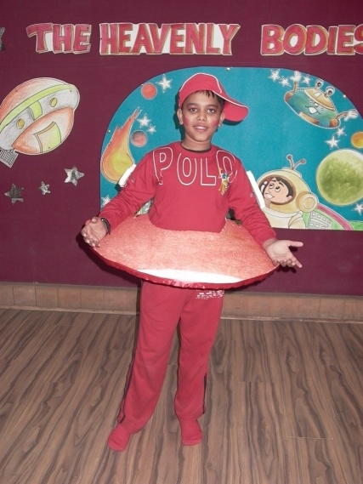 | 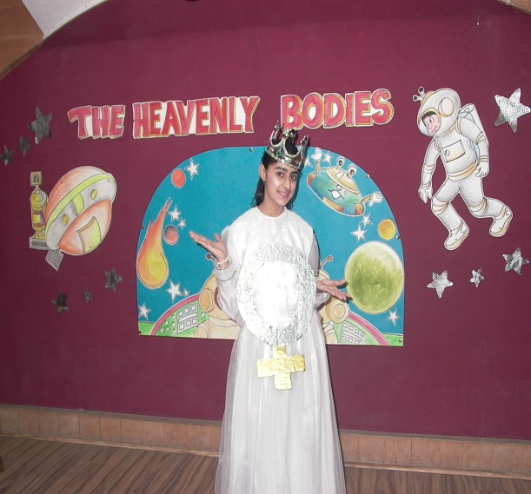 | 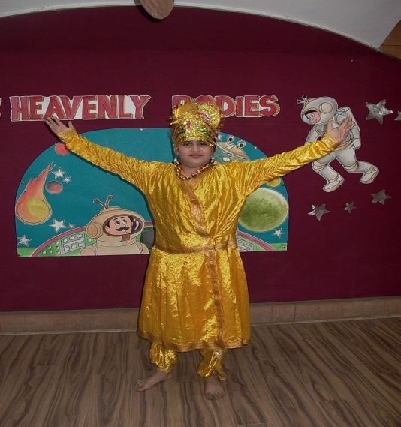

S.NO. | NAME OF THE STUDENTS | CLASS & SECTION | POSITION
1. | KAIVALAYA SAXENA | VI - E | I
2. | RIYA ARORA | VI – B | II
3. | CHHAVI SAKUJA  SARIKA NANGIA | VI – C  VI – E | III
4. | KAMALPREET KAUR  SAHIL CHAWLA | VI – B  VI - E | CONSOLATION

