AMERICAN EMBASSY SCHOOL
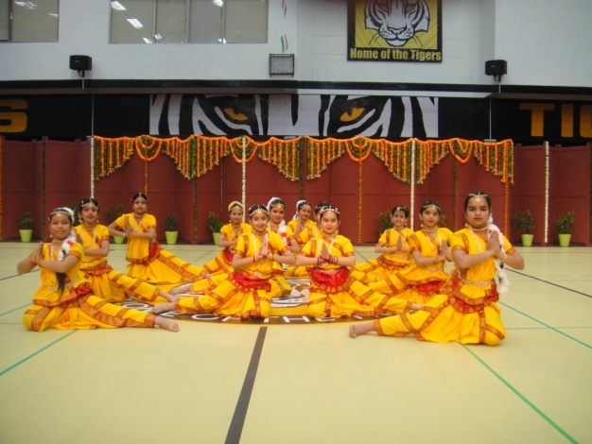 | 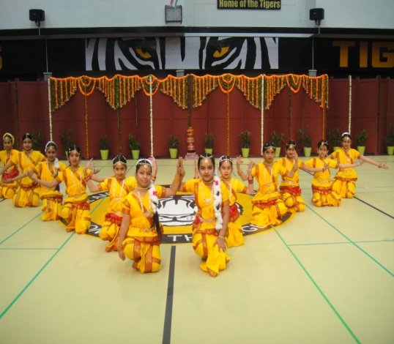 | 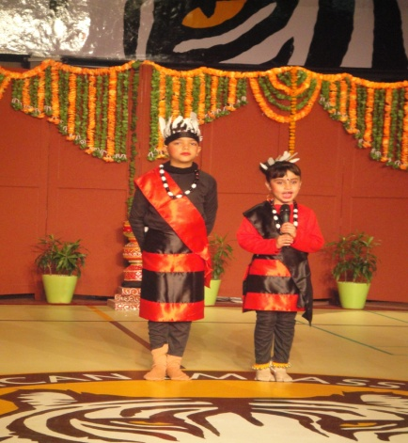

Freedom in mind,
Faith in words,
Memories in our soul,
Pride in our heart

Let us salute the nation on our Republic Day.
The students of our school got the opportunity to showcase their talent on the occasion of Republic Day Celebration at American School, Chanakya Puri, on 22nd January 2013. Children gave a scintillating dance performance and left the audience mesmerized through their impeccable show. Their efforts were appreciated by the faculty of America School.

