CLASS - VII
ACTIVITY – MY DREAM CANVAS
(FEVICOL PAINTING)
RESULT

DATE: 16.10.2012

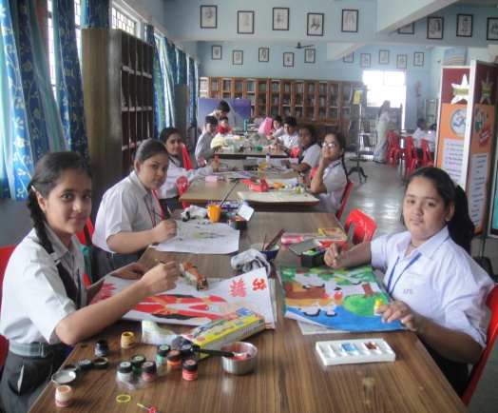 | 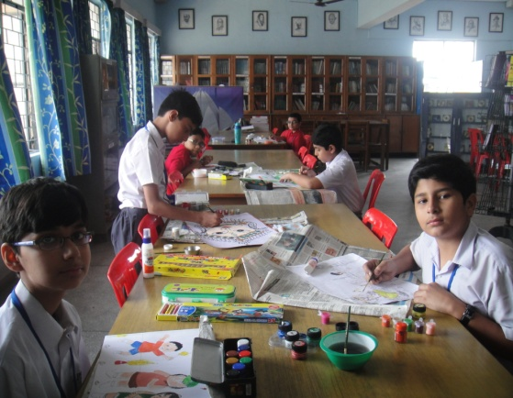 | 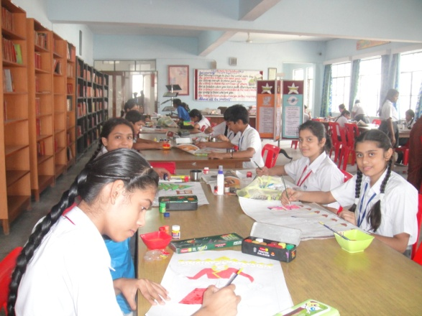

S.NO. | NAME OF THE STUDENTS | CLASS & SECTION | POSITION
1. | HIMANI ARORA  VATSAL NANDA | VII C  VII B | I
2. | DEVANSHI MAURYA  PRANJALI GARG | VII C  VII B | II
3. | ANMOL DUREJA  DEEPANSHI CHAWLA  SHEENAM BERRY | VII B  VII D  VII E | III
4. | HIMANSHU SHARMA  MAHEK CHAGTI  MUSKAN VIRDI | VII C  VII A  VII E | CONSOLATION

